United Arab Emirates  Department of Education and Knowledge  Bani Yas International Pr`ivate School |  | دولة الإمارات العربية المتحدة  دائرة التعليم والمعرفة  مدرسة بني ياس الدولية الخاصة

Academic Year 2018-2019 العام الدراسي Grade: 4
Subject: computer | Computer Revision sheets
– Write in down table power point main screen parts
( Menu bar – title bar – tool bar- work area – outline pane-status bar )
11
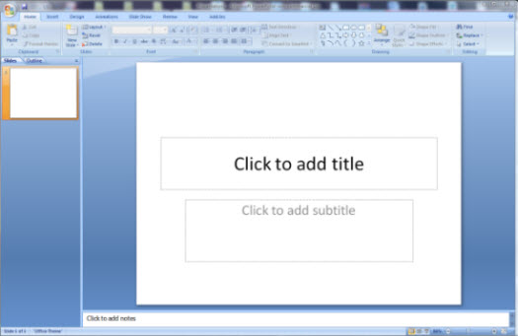
6
5
4
3
2
1 | Title bar
2 | Menu bar
3 | Outline Pane
4 | Work area
5 | Tool bar
6 | Status bar

United Arab Emirates  Department of Education and Knowledge  Bani Yas International Private School |  | دولة الإمارات العربية المتحدة  دائرة التعليم والمعرفة  مدرسة بني ياس الدولية الخاصة

complete the following table :
( word – excel –power point –sound files –picture files-video files )
File type | File Extension f
Picture files | .bmp
Word | .doc
Excel | .xls
Power point | .ppt
Sound files | .mp3
Video files | .mp4

true or false
1-to save a presentation in power point open file menu and choose save ( true )
2-the explorer is a program used to arrange files and folders inside the computer ( true )
3-file name consist of two parts separated by a dot ( true )
4-you can use power point program to create presentation ( true )
5- you cannot change data or time for your computer ( false )
6- to get information about your computer properties left click on my computer icon and choose properties ( false )
7- power point is a presentation program ( true )
8-we insert picture in power point from design menu (false)

Match the word to the function
Windows explorer to arrange files and folders
Help and support to get help if you have problem in your computer
Control panel to control system setting
Search to find your saved files
Run to open program directly

Fill in the blanks with answers :
1-power point is …………………. Program
2- to insert new slide in power point click on insert menu and choose ……………….
3- to make text bold click on ……….. in font window
4- to start the show from beginning in power point presentation click on ……….. from keyboard
5- To save presentation open file menu and choose ……….
6- to close power point click on …………….. from keyboard
7-in power point you can insert table from ………. Menu
8- we can add themes from ……….. menu in power point

The answer :
1-apresentation
2-new slide
3- B
4- F5
5- Save
6-Alt +F4
7- Insert
8- design

